Big Mountain’s combination of natural features and infrastructure means that there is significant room for increase in ticket price that would still be good value for customers. In order to offset the increase in operational cost from the new chairlift investment, Big Mountain would need to raise prices by $0.88/ticket according to our model. All the natural features and infrastructure that that most affect ticket price differences across the ski resort market are ones that Big Mountain is a national leader in. Our model suggests that, based on these features and infrastructure, Big Mountain could feasibly raise prices to $95.87.

With a vertical drop of 2353 feet, Big Mountain has one of the higher vertical drops in the market, providing a great experience for everyone on the bunny slopes and the adrenaline junkies. With a snow making capacity of 600 acres, Big Mountain can guarantee more slopes open more often, so people can enjoy all season long. With over 100 runs, the longest being almost 3.5 miles, Big Mountain has plenty to explore and customers can do more skiing and less waiting in chair lift lines. In all of these metrics, which rank amongst the most influential with regards to ticket pricing, Big Mountain near the top. It is for this reason, that we believe Big Mountain could significantly increase their ticket pricing, and still be value for money without changing anything about the resort. This would easily offset the cost of the new chair lift investment.

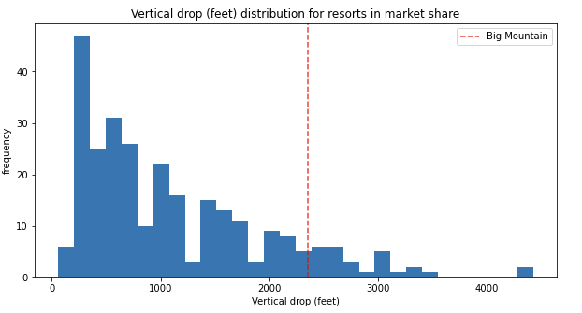 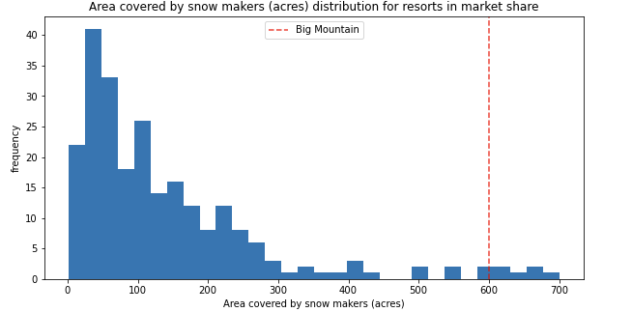

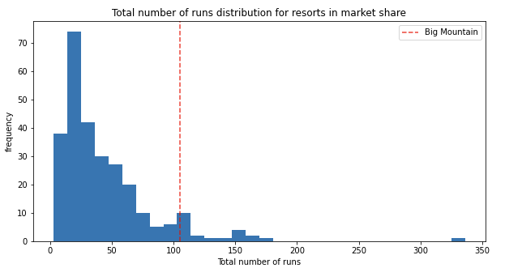 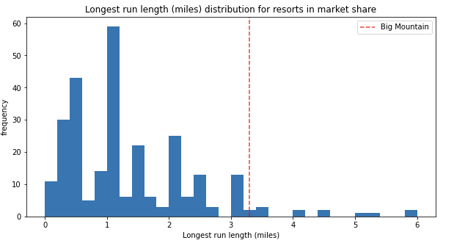

Now, based on our model, there are cost cutting measures and other resort changes that Big Mountain could undertake to offset operational cost increases. Big Mountain could experiment with lowering ticket price and closing 1, 2 or 5 runs, and see how that affects operational cost. Based on our model there would no difference between closing 3, 4, or 5 runs to the ticket price. Additionally, Big Mountain could increase it’s vertical drop by 150 feet and build another chair lift. Our model indicates that this would support a ticket price increase of $1.99, which would easily offset the new chair lift investment and would further boost one of the more profitably features of the resort.

All of this is to say that the Big Mountain Resort is presently underpriced and has significant room for ticket increased based on the most profitable features according to our model. There are also a few options for operational changes that could be made instead or in conjunction with a ticket price increase to ensure that Big Mountain resort is priced appropriately given the experience it provides all it’s guests.